Goal: Define a realistic set of parameters for the particles
Notes: Too tight and the bacteria branching would not be visible
Log:
- Control Ro 8 (radius inter centre) ro 4 (particle radius) – C0 n800 (fast computation)
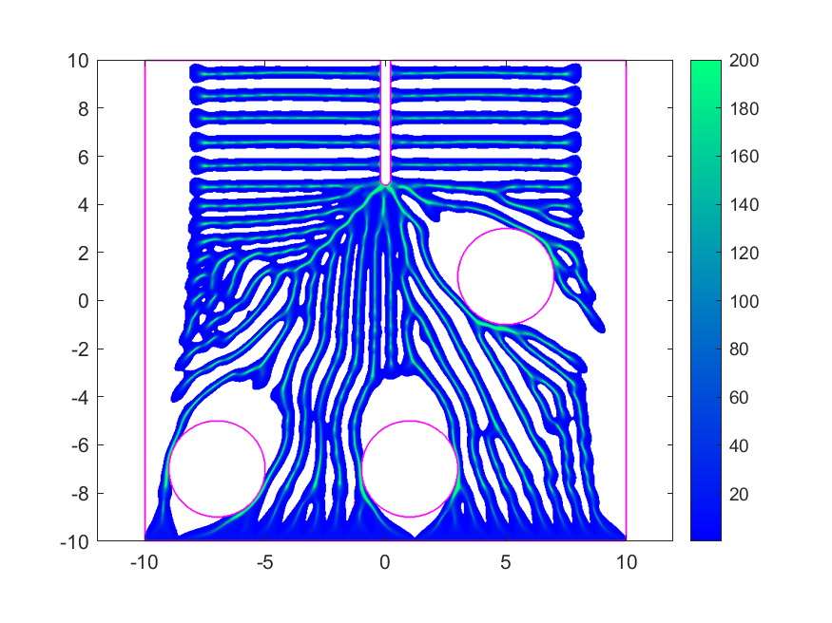
Particles way too big
- Control 2 Ro 4 ro 2

